THEATRE ARTS
ADVANCED MUSICAL THEATRE AUDITIONS

Worksheet for Monologue and Song

Name of Applicant: ______________________________________________________

Grade: __________________

Monologue

Name of Character: ___________________________________________________

Play: _________________________________________________________________

Describe the situation you are in as this character, the relationship you have to the person to whom you are speaking and what you hope to get from that person. If you are speaking to yourself, why? What are your objectives?

What about this selection attracted you as a person and an actor?

Song

Name of Character: ___________________________________________________

Play: _________________________________________________________________

Describe the situation you are in as this character, the relationship you have to the person to whom you are singing and what you hope to get from that person. If you are singing to yourself, why? What are your objectives?

What about this selection attracted you as a person and an actor?

Auditions

Musical Theatre Fall 2017

Please fill in the first five lines. Auditor will fill in the rubric during and after your audition.

Actor’s Name __________________________________________________________________

Name of Character (monologue): __________________________________________________

Play: _________________________________________________________________________

Name of Character (song): ________________________________________________________

Play: _________________________________________________________________________

Memorization

__________/10

Are the pieces memorized (well)?

Character

__________/25

Are the characters well developed? Are the characters theatrically believable?
Are the characters consistent and played with levels? Is there conflict?
Are the goals and obstacles evident and played appropriately? Contrast between characters?

Body

__________/20

Use of body (including gestures, movement, shape, etc.) Demonstration of control of instrument?

Voice

__________/20

Use of voice (volume, pronunciation, vocal variation, etc.) Demonstration of control of instrument?

Overall Performance

__________/25

Is there investment? A demonstration of creativity? Do the pieces work best for the actor? Are they the appropriate length? Is there investment? Creativity? Does the actor exude confidence/presence? Is the actor fully in control of the situation? Is there a demonstration of work and having fun? Overall effectiveness?

Comments

Actor Contract for Advanced Musical Theatre

I, __________________________________________, agree to the following:

- I will do my best to attend all scheduled class sessions and rehearsals. This means staying healthy and making every effort not to schedule appointments during class time. Missing sessions will, of course, affect casting.

- If I am unable to attend rehearsal because of injury or illness, I will notify the director as soon as possible.

- I will be on time for all technical rehearsals, dress rehearsals, and performances that are scheduled outside of class time. I will show up to call on time (typically one hour prior to performance) and will not be late.

- I will wear clothing appropriate for training and rehearsal.

- I will be prepared to take notes during rehearsal. Notes will include blocking and acting instructions. All of my notes will be written and studied during and after rehearsal. These will be collected, a grade assigned, and placed into your portfolio.

- I will learn my lines and my songs by the date set by the director and vocal director.

- I will treat my work in this class with seriousness and professionalism, recognizing that my behavior affects others.

- I will expect respect, acceptance, and support from the entire production team and will offer the same to them.

- I understand that only people involved with the production are allowed backstage during rehearsals and performance.

- I will clean the backstage area after performances and will not be allowed to leave until the stage manager/director excuses me. Similarly, I will help strike the set as requested.

- I recognize that I was selected to participate in this course and that this is a privilege, not a right. As always, the intent is to have fun and push my work forward.

I agree to these rules and will conduct myself in a professional manner during my class, rehearsal and performance time. I understand that breaking this contract will affect my grade and be grounds for dismissal from the production.

Signature of Actor __________________________________________ Date ______________

Signature of Parent __________________________________________ Date ______________

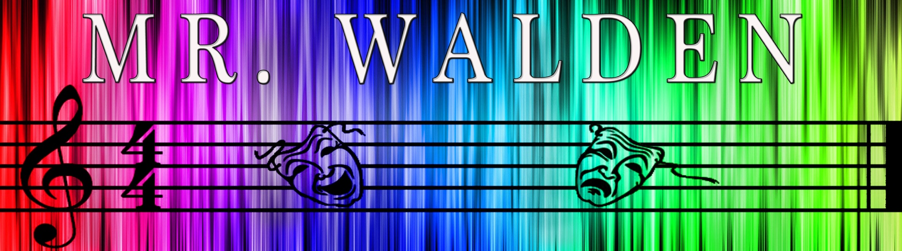
🎵 No a cappella auditions. You must bring either an accompaniment track or the sheet music for your song in your key.
🎵 One verse and one chorus of the song are required.
🎵 It must be from the musical theatre repertoire: Broadway, Off-Broadway or West End. It may not be a song from a musical made as a movie but which was not on stage.

Advanced Musical Theatre
August 2017

Full Name

Grade

List solo singing experience (including lessons)

List choir/chorus experience

List theatre experience

List dance experience

List any instruments you play and for how long

Fill out the other side too

List any musicals you have seen live on stage and where you saw them.

What is your favorite musical and why?

Which musical theatre song do you wish you could work on?

What character from a musical would be your dream role?

For Teacher use only
P/I
H/L
A
S
E
O

